NETBALL ATHLETE PERFORMANCE IDENTIFICATION POLICY 2023 / 2024

Purpose and scope of policy
The purpose of the East Essex County Selection Policy and Procedures is to ensure that the right athletes can be selected onto the England Netball Player Pathway programmes (Appendix 4) and provided with training through the Player Development Programmes to fulfil their individual potential, which may be reaching the top tiers of the Player Pathway and achieving selection to represent England at age group or senior level.
This Selection Policy sets out how netball athletes (Athletes) are selected by East Essex County Netball Associations into the East Essex County Player Pathway Programmes (PDP) (County Under-15 Player Development programme and County Under-13 Player Development programme and associated activity)
Appendix 1 contains the Glossary of Defined Terms. Those Terms will be applied throughout this document.

Performance Mission and Objectives
England Netball is committed to setting new standards for netball, showcasing inspiring performances by outstanding players in international tournaments. It will support the Roses to achieve recognition and respect as the world’s best female sports team and prepare future Roses for the specific demands of international netball to ensure that there is an oversupply of Roses-ready players available for selection.

It will develop robust talent recruitment systems and processes that allow talented players from all backgrounds to be identified and to access the pathway.

It’s performance ambitions are:
- The Roses consistently beating other top-ranked nations and winning back-to-back Commonwealth Games and Netball World Cup titles
- The Roses being held in esteem for a clear, recognisable and respected ‘Roses Way’ being demonstrated daily by players on and off-court
- World-class depth of Roses-ready players in all positions, competing for places in the Roses team
- The Roses team being made up of players from a range of backgrounds and locations

- East Essex CNA aspires to be a major feeder to the Saracens Mavericks Academy squads (Appendix 3). To achieve that goal we must develop more performance athletes who can function both individually and as a leading team. This aspiration provides the beacon to guide all Performance activity and decision- making, including the management & delivery of the identification, and development of athletes within the County Player Pathway Programmes.
- The development of a leading county is dependent upon building a Squad of athletes with depth and breadth across all positions on the court and the ability to function as of individual national level athletes in a team environment. (Appendix 5)

INTRODUCTION

  - The East Essex County Netball Association Selection Policy is inclusive of identification and selection across the County Player Pathway Programmes (County Under-15 Player Development programme and County Under-13 Player Development programme and associated activity).
  - The Selection Policy and the associated procedures will be transparent and accessible. At all times the Policy and Procedures will be widely communicated and adhered to and, made available to all members of the East Essex County Netball Association. The Policy will be always available on the county websites, and directly to all athletes entering the selection process.
  - The Selection Panel responsible for selecting athletes into the East Essex County Player Pathway Programme is to be agreed by the CNA Committee

PRINCIPLES OF SELECTION
The following principles will be applied while carrying out the Selection Process:
- The East Essex County Selection Policy and Procedures employs an open, transparent and equitable process that gives all athlete a fair chance to challenge for county player pathway programme selection.
- The East Essex County Selection Policy and Procedures will be consistent. At all times the provisions of the Policy and Procedures will be applied consistently and rigorously. It is the responsibility of the East Essex County Netball Association to ensure this. The East Essex County Netball Association may delegate this responsibility in writing to the East Essex County Head Selector, County Player Development Lead or Development Manager.
- Selection will be based on merit and the need to achieve the agreed objectives of East Essex County Netball Association (Appendix 2)
- No Athlete has the right or expectation to on-going selection for East Essex County Player Development programmes, at any time.
- The Selection Panel, as defined in paragraph 3 bellow, has the right to determine, at its sole discretion, when it will reselect athletes into East Essex County Player Pathway Programmes
- Athletes will, be subject to deselection if they breach the code of conduct and all other relevant East Essex County Netball Association’s policies and regulations.
- The East Essex Head County Selector has the right to Invite athletes from outside the Player Pathway Programmes, to be observed and considered by the Selection Panel for inclusion in the Player Pathway Programme, based upon Selection Criteria set out in Appendix 2.
- The Player Pathway Selection Process is open at every level. This means that new athletes may be invited into a County PDP at any time by 31st March 2023 if correct procedures are followed. The procedures for East Essex County Player Pathway Programme Selection are outlined in detail under paragraph 6 below.

ELIGABILITY
To be eligible for Selection into the East Essex County Player Pathway Programme, an athlete must be:
- the eligibility criteria as set by the CNA (Appendix 5)
- Meet the Selection Criteria (Appendix 2)
- Clear of any ban under UK Anti-Doping Regulations
- Be selected / screened via the East Essex County Netball Association Selection and screening process

SELECTION PANEL
- All Selection panel members, including the Chair, will be appointed based upon competency for the role.
- Selection Panel members will be appointed by the East Essex County Player Development Lead/Manager ratified by the County Head Selector
- The Selection Panel for East Essex County Player Pathway Programmes will consist of the coaches involved in the delivery of the player pathway programmes and independent selectors:
    - East Essex County Under-15 Player Development programme: County Head Selector, County Under-15 Player Development programme Head Coach, Appointed Other (x1) (Recommendation: Appointed Other – Selector of the VNSL Team to which the County is assigned)
    - East Essex County Under-13 Player Development programme; County Head Selector, County Under-13 Player Development programme Head Coach, County Under-15 Player Development programme Head Coach OR Appointed Other (x1)
- Selectors will have attended the England Netball Athlete Identifier Workshop, or be deemed by the East Essex County Player Development Lead/Manager to have significant experience and have been briefed by the East Essex County Player Development Lead on the selection criteria prior to the selection event
- In making final selections into the East Essex County Player Pathway Programmes, of which there should always be an odd number, will have an equal vote.
- Ratio of 1 selector per 8-12 players – Each selector collate evidence for the selection panel to make final decisions.
- The Selector Panel members are accountable to the East Essex County Head Selector/Development Lead and ultimately the East Essex County Netball Association for ensuring that the Selection
Policy and procedures associated are applied in a fair and appropriate manner.

DE-SELECTION AND ATHLETE WITHDRAWAL
- Athletes selected into a County Player Pathway Programme will be able to access a range of training opportunities through their County Player Development programme as determined by the England Netball Roses Development Framework.
- The ongoing failure of any athlete to meet training requirements could result in de-selection. This shall be decided by the same Selection Panel outlined under paragraph 3.
- An athlete may choose to withdraw from a County Player Pathway Programme voluntarily. Such a withdrawal must be done in writing to the Head Coach, County Head Selector or County Netball Association directly.

THE SELECTION PROCESS
  - Athletes will be identified and nominated for County Player Pathway Programme Selection by one of the following possible Nominators (see Definitions
- County Under-15 Player Development programme; County Selector, County Scouts, County Under-15 Player Development programme Head Coach, County Under-13 Player Development programme Head Coach and Trained Identifiers
- County Under-13 Player Development programme; County Selector, County Under-13 Player Development programme Head Coach, County Scouts and Trained Identifiers
  - Athlete performance at designated Selection Events will be observed and assessed independently and against the Selection Criteria, as set out in Appendix 2
  - Following completion of the Designated Selection Events listed in this Policy, the Coach might consult with other identified coaches and take into account any relevant input from them.
  - The Coach will meet with the Selection Panel to discuss the nominations and provide the opportunity for them to check and challenge and ensure Selection Decisions are evidence based on the Selection Criteria.
  - Individual athlete’s inclusion in the relevant Player Pathway Programme is decided on a majority vote by all members of the Selection Panel.
  - All athletes involved in the selection process will be informed of their individual selection outcome in writing (either electronically and/or by letter) by the County Netball Association who will have been informed of the Selection Panel’s decisions by the County Head Selector.
  - At any time, any athlete involved in the selection process may seek further clarification from the County Head Selector or another member of the Selection Panel.

DESIGNATED SELECTION EVENTS
The full process is:
- There may be a designated Screening Day / evenings for a long squad set by the County Netball Association
- And / or a designated Screening Day / evenings for final selection (minimum of 20 athletes) – September 2023
- Any athlete that was not identified at the selection events but has been nominated to the County Player Development Lead will be observed during the county player pathway programme season by 31st March 2023 and may be invited to join the County Player Pathway Programme by this point.

GRIEVANCE AND APPEALS PROCESS
- Appeals can only be submitted by a non-selected athlete on the grounds that
- the process outlined within this Policy has not been adhered; or
- the process failed to take into consideration relevant information; or
- the process failed to take into account relevant information, which was available at the time, which the Selection Panel did not consider; or
- Any appeal against a selection decision into a County Player Pathway Programme shall be made within five working days of the public announcement of the Squad, in writing to the Chair of the County Netball Association. If a resolution cannot be found, the appeal may be escalated to the Performance Department at England Netball. England Netball will decide only if the selection decision should stand or if another opportunity to attend a County Player Pathway Programme Selection event or activity should be made available to the athlete by the County Netball Association. England Netball’s decision on any appeal is final.

APPENDICES
Appendix 1 Glossary of Terms
Appendix 2 Selection Criteria (roles and responsibilities of players)
Appendix 3 VNSL Team Player Pathway Programmes
Appendix 4 England Netball Player Pathway
Appendix 5 Eligibility criteria

Appendix 1 - Glossary of Terms
Term | Definition
Athlete | Netball Players
Programme | This includes on court and off court activities for player pathway athletes
Selection Criteria | Statements relating to skills, attributes and games sense used to select into the County PDP’s
Selection Panel | Personnel appointed by the County Netball Association to make selection decisions
County Player Development Programme Head Coach | Qualified coach appointed by the County Netball Association to deliver the County Player Development Programme, directed by England Netball
County Player Development Programme Assistant Coach | Qualified coach appointed by the County Netball Association to support the delivery of the County Player Development Programme, directed by England Netball
County Under-15 Player Development Programme (PDP) | A weekly individualised training environment for athletes usually aged between 14-15, delivered between September and May
County Under-13 Player Development Programme (PDP) | A fortnightly individualised training environment for athletes usually aged between 12-13, delivered between September and May.
County Netball Association (CNA) | An autonomous member’s organisation, affiliated to England Netball. Where an agreement exists, CNAs act as the Player Pathway delivery partner to England Netball for the County Player Development Programmes
County Player Development Programme Selection event or activity | An event or activity whereby an athlete can be observed by a Selection Panel to make an assessment on their suitability to enter, remain or move up the Player Pathway. This event or activity may take a variety of different forms
County Player Pathway Programmes | England Netball directed County Under-15 Player Development programme and County Under13 Player Development programme
County Player Development Lead | To oversee and ensure the effective delivery of County Player Pathway programmes on behalf of the County Netball Association
County Scouts | Identified trained (AIW) individuals responsible for identifying and nominating athletes to attend County Player Pathway Programmes selection events or activities
Nominators | A group of identified and trained (AIW) individuals responsible for nominating athletes to attend a County Player Pathway Programmes selection event or activity, normally consisting of the County Selector, County Scouts, County U15 PDP Head Coach, County U13 PDP Head Coach and Trained Identifiers (coaches/schoolteachers)
Trained Identifiers | Identified trained (AIW) individuals responsible for identifying and nominating athletes to attend County Player Pathway Programmes selection events or activities.
County Head Selector | An identified trained (AIW) individual with responsibility for the selection and de-selection of athletes into the County Player Pathway Programmes through selection events or activities. Appointed by County Netball Association (or a suitable deputy appointed by the Player Development Lead in the absence of the County Head Selector)

Appendix 2 Selection Criteria (roles and responsibilities of players)

SELECTION CRITERIA
Whenever selecting Players for the East Essex County Player Pathway Programme, the Selection Panel shall apply in all Screening activities:
- Evidence of Skill or Quality
- Demonstrate Consistency
- Demonstrate Under Pressure
- Demonstrate in Multiple Context with Consistency
When selecting athletes for the England Netball Player Pathway programmes, at any level the Selection Panel shall apply the core playing competencies, personal qualities and other considerations listed below.
- Movement and Ball Skills Criteria
- Invasion Games: Game sense Criteria
- Match Play: Roles and Responsibilities Criteria

MOVEMENT & BALL SKILLS CRITERIA

Catch | Pass | Footwork | Movement Skills
One handed control Two handed control | Release Point  One handed and two handed  From both sides | Take Off  Landing  Jumping  Footwork Rule | Change of Pace  Change of Direction  Multi Directional

Take Off | Demonstrate efficient technique from a stationary and moving start  - Straight movement forward and backward  - Diagonal movement to the left and right
Footwork | - Demonstrate efficient running technique  - Able to sprint and change direction  - Side step  - Speed of footwork  - Recovery footwork  - Working a number of combinations  - Turning from a sprint movement
Jumping | - Demonstrate efficient technique  - Able to jump off left or right foot  - Able to jump from both feet simultaneously  - Able to turn in the air
Landing | - Demonstrate safe and balanced technique  - Able to land on left or right foot  - Able to land on both feet simultaneously  - Able to pivot in all directions with outside turn
Ball Handling | - Catching 2 and 1 handed.  - Passing 2 handed and 1 handed and variety.  - With and without a defender

GAME SENSE CRITERIA

ATTACK | DEFENCE | BEHAVIOURS
Transition  Width/Depth  Options/Choices  Ball Side  Maintaining Possession | Transition  Winning Ball  Working Together  Delay / Deny Opportunity | Thinking  Patience  Never Give up  Leadership

Match Play: Roles and Responsibilities Criteria - The ROLES & RESPONSIBILITIES of the playing positions for County Under 15 and Under 13 Player Development programme
GS | Movement and Ball Handling | •  •  • | Change direction & change of pace.  Lands balanced, turns to goal  May be inconsistent in delivering correct pass accurately. Sound catching technique. | Effectiveness in Position | •  •  • | Confident from a range of distances.  Aiming for 80%.  Is generally available when CC hit the circle edge. | Transition | • | Dictates to opponent to limit her availability through the court.
GA |  | •  •  • | Change direction & change of pace.  Lands balanced, turns to goal  May be inconsistent in delivering correct pass accurately. Sound catching technique |  | •  •  • | Confident from a range of distances.  Aiming for 80%.  Is generally available when CC hit the circle edge. Is generally available 1st phase on Centre Pass when required. |  | • | Dictates to opponent to limit her availability through the court.
WA |  | •  •  • | Change direction & change of pace.  Lands balanced, turns to goal  May be inconsistent in delivering correct pass accurately. Sound catching technique |  | •  •  • | Is generally available 1st phase on Centre Pass when required.  Accurate feed and can keep possession.  Generally available on circle edge. |  | • | Dictates to opponent to limit her availability through the court and may take interceptions.
C |  | •  •  • | Change direction & change of pace.  Lands balanced, turns to goal  May be inconsistent in delivering correct pass accurately. Sound catching technique |  | • •  • | Deliver Centre pass.  Links and connects both attack defence.  Accurate feed and possession.  Generally available on circle edge. |  | • | Shows signs of working effectively with the WD for effective 2 on 1 at the centre pass.
WD |  | •  •  • | Change direction & change of pace.  Lands balanced, turns to goal  May be inconsistent in delivering correct pass accurately. Sound catching technique |  | •  •  • | Puts pressure on receipt of WA on 1st phase of Centre pass.  Dictates WA movement in the attacking third and puts pressure on feeds.  Takes interceptions off opponent. |  | • | Transitions from defence to attack providing option for the initial turnover
GD |  | •  •  • | Change direction & change of pace.  Lands balanced, turns to goal  May be inconsistent in delivering correct pass accurately. Sound catching technique |  | •  •  •  • | Puts pressure on receipt of GA on 1st phase of Centre pass.  Limits shot volume.  Takes interceptions off opponent.  Challenges for rebounds |  | • | Transitions from defence to attack providing option for the initial turnover.
GK |  | •  •  • | Change direction & change of pace.  Lands balanced, turns to goal  May be inconsistent in delivering correct pass accurately. Sound catching technique |  | •  •  •  • | Dictates & restricts GS movement.  Limits shot volume.  Takes interceptions off opponent.  Challenges for rebounds |  | •  • | Transitions from defence to attack providing option 1st phase. Delivery of the back line pass with success.

Appendix 3 VNSL Team Player Pathway Programmes
- 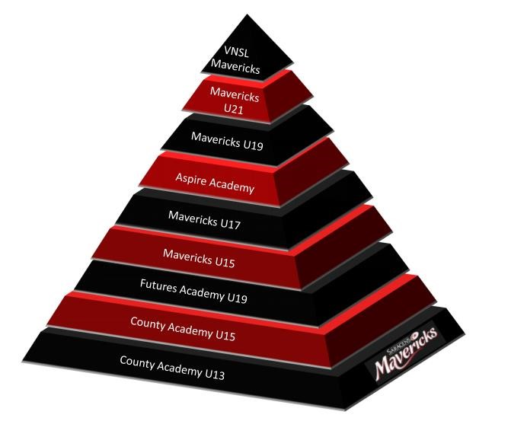

Appendix 4 England Netball Player Pathway
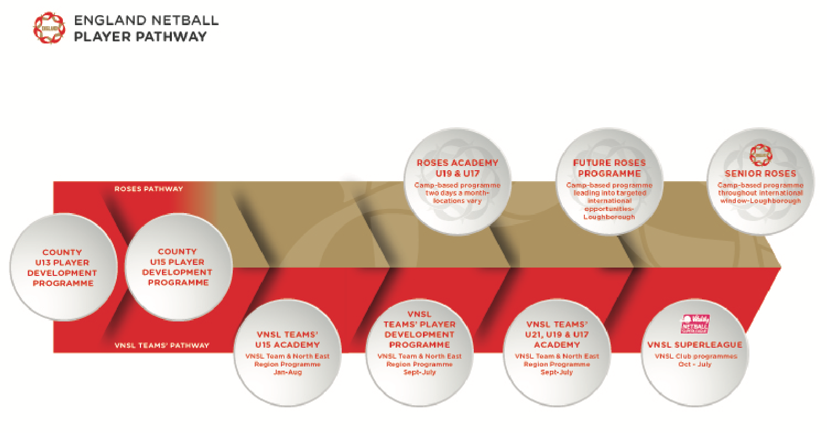

Appendix 5 – County Player Pathway Programmes Eligibility Criteria

- Be at the correct age at the time of screening for that season.
  - Under-13 as of 23:59 on 31st August 2023, School years 8 and below
  - Under-15 as of 23:59 on 31st August 2023, school year 10 and below
- Be affiliated to England Netball and have active membership to England Netball prior to the selection event.
- Be affiliated to CNA on Engage
- To have completed the trial application form prior to the deadline
  - If injured or unavailable for the set date, still complete an application form and then follow up with an email to the County Player Development Manager essexperformancelead@gmail.com with a request for an alternative date.
  - The County Player Development Lead and Manager reserve the right to decline an alternative date if it falls outside of the scope of their annual plan.

